Міністерство освіти і науки України

**Прикарпатський національний університет**

**імені В.Стефаника**

*Факультет математики та інформатики*

*Кафедра інформаційних технологій*

*Людинно-машинна взаємодія*

Лабораторна робота № 7

Тема: Робота з контейнерами в середовищі Qt Creator: QList, QLinkedList

*Варіант 2*

Виконав: ***Гук Д.П.***

Група ІПЗ-31

Дата:12 листопада 2023 р.

Викладач: Пікуляк М.В.

Івано-Франківськ – 2023

**Мета роботи:**

Отримати навички роботи з контейнерами QList, QLinkedList в ICP “Qt-Creator”.

**Завдання для виконання :**

1. Заповнити список випадковими елементами і реалізувати

видалення елементів з позицій з N по K.

2. Заповнити зв’язний список випадковими елементами і

впорядкувати їх за спаданням.

3. Створити консольний проект для роботи з двохзв’язним

списком (оголосіть екземпляр класу QLinkedList <int> list). Заповніть його

випадковими значеннями і продемонструйте в ньому роботу таких алгоритмів STL:

а) count (first, last, value) – повертає значення, яке показує скільки разів

елемент зі значенням value входить в послідовність, задану ітераторами;

б) reverse (first, last) – переставляє елементи в зворотному порядку;

в) iter_swap (first, last) – міняє місцями значення елементів, на які вказують

ітератори.

**Тексти скриптів і зображення діалогових вікон QtCreator з виконаними завданнями :**

**Завдання №1:**

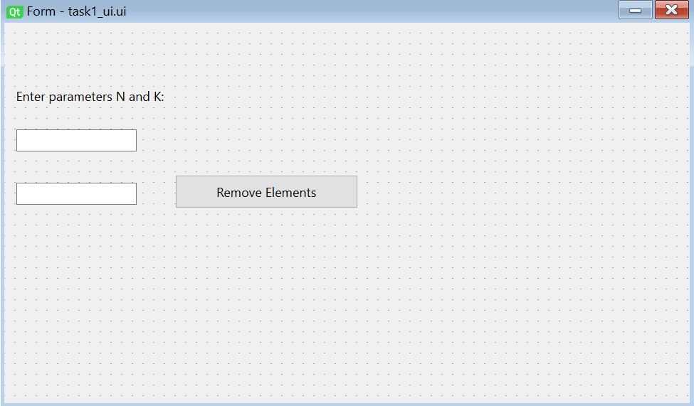

import random  
import sys  
  
from PyQt6 import QtCore, QtWidgets  
  
  
class Ui_Form(object):  
 def setupUi(self, Form):  
 Form.setObjectName("Form")  
 Form.resize(642, 357)  
 self.label = QtWidgets.QLabel(parent=Form)  
 self.label.setGeometry(QtCore.QRect(11, 61, 151, 16))  
 self.label.setObjectName("label")  
 self.label_2 = QtWidgets.QLabel(parent=Form)  
 self.label_2.setGeometry(QtCore.QRect(10, 270, 551, 61))  
 self.label_2.setText("")  
 self.label_2.setObjectName("label_2")  
 self.lineEdit = QtWidgets.QLineEdit(parent=Form)  
 self.lineEdit.setGeometry(QtCore.QRect(11, 100, 113, 21))  
 self.lineEdit.setObjectName("lineEdit")  
 self.lineEdit_2 = QtWidgets.QLineEdit(parent=Form)  
 self.lineEdit_2.setGeometry(QtCore.QRect(11, 150, 113, 21))  
 self.lineEdit_2.setObjectName("lineEdit_2")  
 self.pushButton = QtWidgets.QPushButton(parent=Form)  
 self.pushButton.setGeometry(QtCore.QRect(160, 143, 171, 31))  
 self.pushButton.setObjectName("pushButton")  
 self.pushButton.clicked.connect(self.remove_elements)  
 self.label_3 = QtWidgets.QLabel(parent=Form)  
 self.label_3.setGeometry(QtCore.QRect(10, 200, 551, 61))  
 self.label_3.setText("")  
 self.label_3.setObjectName("label_3")  
  
 self.retranslateUi(Form)  
 QtCore.QMetaObject.connectSlotsByName(Form)  
  
 def retranslateUi(self, Form):  
 _translate = QtCore.QCoreApplication.translate  
 Form.setWindowTitle(_translate("Form", "Task1"))  
 self.label.setText(_translate("Form", "Enter parameters N and K: "))  
 self.pushButton.setText(_translate("Form", "Remove Elements"))  
  
 def remove_elements(self):  
 try:  
 N = int(self.lineEdit.text())  
 K = int(self.lineEdit_2.text())  
  
 if N >= K:  
 self.label_2.setText("N must be less than K")  
 return  
  
 random_list = [random.randint(1, 100) for _ in range(20)]  
 self.label_3.setText("Random List: " + ', '.join(map(str, random_list)))  
  
 if K > len(random_list):  
 K = len(random_list)  
  
 del random_list[N - 1:K]  
  
 self.label_2.setText("Updated List: " + ', '.join(map(str, random_list)))  
  
 except ValueError:  
 self.label_2.setText("Please enter valid integers for N and K")  
  
app = QtWidgets.QApplication(sys.argv)  
task3_dialog = QtWidgets.QDialog()  
ui = Ui_Form()  
ui.setupUi(task3_dialog)  
task3_dialog.show()  
sys.exit(app.exec())

**Завдання №2:**

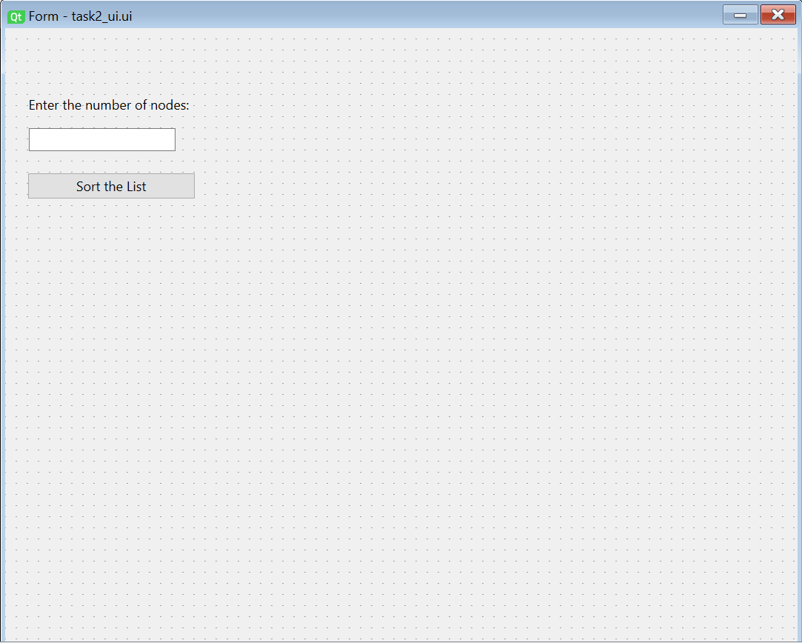

import random  
import sys  
from collections.abc import Iterable  
  
from PyQt6 import QtCore, QtWidgets  
  
class Node:  
 def __init__(self, data=None):  
 self.data = data  
 self.next = None  
  
class LinkedList(Iterable):  
 def __init__(self):  
 self.head = None  
  
 def __iter__(self):  
 current = self.head  
 while current:  
 yield current.data  
 current = current.next  
  
 def append(self, data):  
 new_node = Node(data)  
 if not self.head:  
 self.head = new_node  
 return  
 current = self.head  
 while current.next:  
 current = current.next  
 current.next = new_node  
  
 def sort_descending(self):  
 if not self.head or not self.head.next:  
 return  
  
 def merge_sort(node):  
 if not node or not node.next:  
 return node  
  
 middle = get_middle(node)  
 next_to_middle = middle.next  
 middle.next = None  
  
 left = merge_sort(node)  
 right = merge_sort(next_to_middle)  
  
 return merge(left, right)  
  
 def merge(left, right):  
 result = None  
  
 if not left:  
 return right  
 if not right:  
 return left  
  
 if left.data >= right.data:  
 result = left  
 result.next = merge(left.next, right)  
 else:  
 result = right  
 result.next = merge(left, right.next)  
  
 return result  
  
 def get_middle(node):  
 if not node:  
 return node  
  
 slow = node  
 fast = node  
  
 while fast.next and fast.next.next:  
 slow = slow.next  
 fast = fast.next.next  
  
 return slow  
  
 self.head = merge_sort(self.head)  
  
  
class Ui_Form(object):  
 def setupUi(self, Form):  
 Form.setObjectName("Form")  
 Form.resize(713, 571)  
 self.label = QtWidgets.QLabel(parent=Form)  
 self.label.setGeometry(QtCore.QRect(21, 61, 171, 16))  
 self.label.setObjectName("label")  
 self.lineEdit = QtWidgets.QLineEdit(parent=Form)  
 self.lineEdit.setGeometry(QtCore.QRect(21, 90, 132, 21))  
 self.lineEdit.setObjectName("lineEdit")  
 self.pushButton = QtWidgets.QPushButton(parent=Form)  
 self.pushButton.setGeometry(QtCore.QRect(20, 130, 151, 24))  
 self.pushButton.setObjectName("pushButton")  
 self.pushButton.clicked.connect(self.sort_linked_list)  
 self.label_2 = QtWidgets.QLabel(parent=Form)  
 self.label_2.setGeometry(QtCore.QRect(21, 200, 301, 321))  
 self.label_2.setText("")  
 self.label_2.setObjectName("label_2")  
 self.label_3 = QtWidgets.QLabel(parent=Form)  
 self.label_3.setGeometry(QtCore.QRect(350, 200, 331, 321))  
 self.label_3.setText("")  
 self.label_3.setObjectName("label_3")  
  
 self.retranslateUi(Form)  
 QtCore.QMetaObject.connectSlotsByName(Form)  
  
 def retranslateUi(self, Form):  
 _translate = QtCore.QCoreApplication.translate  
 Form.setWindowTitle(_translate("Form", "Task 2"))  
 self.label.setText(_translate("Form", "Enter the number of nodes: "))  
 self.pushButton.setText(_translate("Form", "Sort the List"))  
  
  
 def sort_linked_list(self):  
 try:  
 num_nodes = int(self.lineEdit.text())  
  
 linked_list = LinkedList()  
 for _ in range(num_nodes):  
 linked_list.append(random.randint(1, 100))  
  
 original_list = "Original List:\n" + ', '.join(  
 str(node) + ('\n' if i % 10 == 9 else '') for i, node in enumerate(linked_list))  
 linked_list.sort_descending()  
 sorted_list = "Sorted List (descending):\n" + ', '.join(  
 str(node) + ('\n' if i % 10 == 9 else '') for i, node in enumerate(linked_list))  
  
 self.label_2.setText(original_list)  
 self.label_3.setText(sorted_list)  
  
 except ValueError:  
 self.label_2.setText("Please enter a valid integer for the number of nodes")  
 self.label_3.setText("Please enter a valid integer for the number of nodes")  
  
  
app = QtWidgets.QApplication(sys.argv)  
task2 = QtWidgets.QDialog()  
ui = Ui_Form()  
ui.setupUi(task2)  
task2.show()  
sys.exit(app.exec())

**Завдання №3:**

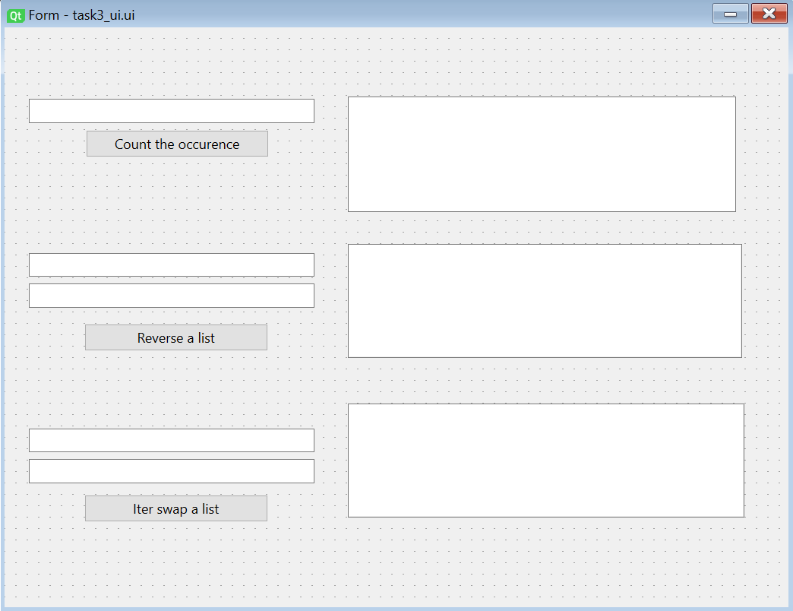

import random  
  
from PyQt6 import QtCore, QtWidgets  
  
class Node:  
 def __init__(self, data):  
 self.data = data  
 self.prev = None  
 self.next = None  
  
class DoublyLinkedList:  
 def __init__(self):  
 self.head = None  
 self.tail = None  
  
 def append(self, data):  
 new_node = Node(data)  
 if not self.head:  
 self.head = new_node  
 self.tail = new_node  
 else:  
 new_node.prev = self.tail  
 self.tail.next = new_node  
 self.tail = new_node  
  
 def count(self, value):  
 count = 0  
 current = self.head  
 while current:  
 if current.data == value:  
 count += 1  
 current = current.next  
 return count  
  
 def reverse(self, start_idx, end_idx, callback=None):  
 if start_idx < 0 or end_idx < 0 or start_idx >= end_idx:  
 return  
  
 current = self.head  
 count = 0  
  
 while count < start_idx:  
 current = current.next  
 count += 1  
  
 start_node = current  
  
 while count < end_idx:  
 current = current.next  
 count += 1  
  
 end_node = current  
  
 while start_node != end_node and end_node.next != start_node:  
 start_node.data, end_node.data = end_node.data, start_node.data  
 start_node = start_node.next  
 end_node = end_node.prev  
  
 if callback:  
 callback()  
 QtCore.QCoreApplication.processEvents()  
  
 def iter_swap(self, first, last, callback=None):  
 first.data, last.data = last.data, first.data  
  
 if callback:  
 callback()  
 QtCore.QCoreApplication.processEvents()  
  
class Ui_Form(object):  
 def setupUi(self, Form):  
 Form.setObjectName("Form")  
 Form.resize(688, 509)  
 self.lineEdit = QtWidgets.QLineEdit(parent=Form)  
 self.lineEdit.setGeometry(QtCore.QRect(21, 63, 251, 21))  
 self.lineEdit.setObjectName("lineEdit")  
 self.lineEdit_2 = QtWidgets.QLineEdit(parent=Form)  
 self.lineEdit_2.setGeometry(QtCore.QRect(21, 198, 251, 21))  
 self.lineEdit_2.setObjectName("lineEdit_2")  
 self.lineEdit_3 = QtWidgets.QLineEdit(parent=Form)  
 self.lineEdit_3.setGeometry(QtCore.QRect(21, 225, 251, 21))  
 self.lineEdit_3.setObjectName("lineEdit_3")  
 self.lineEdit_4 = QtWidgets.QLineEdit(parent=Form)  
 self.lineEdit_4.setGeometry(QtCore.QRect(21, 352, 251, 21))  
 self.lineEdit_4.setObjectName("lineEdit_4")  
 self.lineEdit_5 = QtWidgets.QLineEdit(parent=Form)  
 self.lineEdit_5.setGeometry(QtCore.QRect(21, 379, 251, 21))  
 self.lineEdit_5.setObjectName("lineEdit_5")  
 self.pushButton_3 = QtWidgets.QPushButton(parent=Form)  
 self.pushButton_3.setGeometry(QtCore.QRect(71, 90, 161, 24))  
 self.pushButton_3.setObjectName("pushButton_3")  
 self.pushButton_4 = QtWidgets.QPushButton(parent=Form)  
 self.pushButton_4.setGeometry(QtCore.QRect(70, 260, 161, 24))  
 self.pushButton_4.setObjectName("pushButton_4")  
 self.pushButton_5 = QtWidgets.QPushButton(parent=Form)  
 self.pushButton_5.setGeometry(QtCore.QRect(70, 410, 161, 24))  
 self.pushButton_5.setObjectName("pushButton_5")  
 self.textEdit = QtWidgets.QTextEdit(parent=Form)  
 self.textEdit.setGeometry(QtCore.QRect(301, 61, 341, 101))  
 self.textEdit.setObjectName("textEdit")  
 self.textEdit_2 = QtWidgets.QTextEdit(parent=Form)  
 self.textEdit_2.setGeometry(QtCore.QRect(301, 190, 346, 100))  
 self.textEdit_2.setObjectName("textEdit_2")  
 self.textEdit_3 = QtWidgets.QTextEdit(parent=Form)  
 self.textEdit_3.setGeometry(QtCore.QRect(301, 330, 348, 100))  
 self.textEdit_3.setObjectName("textEdit_3")  
  
 self.retranslateUi(Form)  
 QtCore.QMetaObject.connectSlotsByName(Form)  
  
  
 self.linked_list = DoublyLinkedList()  
  
 values = [random.randint(1, 100) for _ in range(10)]  
 for value in values:  
 self.linked_list.append(value)  
  
 self.pushButton_3.clicked.connect(self.count_elements)  
 self.pushButton_4.clicked.connect(self.reverse_elements)  
 self.pushButton_5.clicked.connect(self.iter_swap_elements)  
  
 def retranslateUi(self, Form):  
 _translate = QtCore.QCoreApplication.translate  
 Form.setWindowTitle(_translate("Form", "Form"))  
 self.pushButton_3.setText(_translate("Form", "Count the occurrence"))  
 self.pushButton_4.setText(_translate("Form", "Reverse a list"))  
 self.pushButton_5.setText(_translate("Form", "Iter swap a list"))  
  
 def count_elements(self):  
 value_to_count = int(self.lineEdit.text())  
 count = self.linked_list.count(value_to_count)  
 self.textEdit.clear()  
 self.textEdit.append(f"The value {value_to_count} appears {count} times in the linked list.")  
  
 def reverse_elements(self):  
 start_idx = int(self.lineEdit_2.text())  
 end_idx = int(self.lineEdit_3.text())  
  
 def callback():  
 self.textEdit_2.clear()  
 self.textEdit_2.append(f"Elements reversed in the specified range (indices {start_idx}-{end_idx}) in the linked list.")  
 self.display_linked_list(self.textEdit_2)  
  
 self.linked_list.reverse(start_idx, end_idx, callback)  
  
 def iter_swap_elements(self):  
 index_1 = int(self.lineEdit_4.text())  
 index_2 = int(self.lineEdit_5.text())  
  
 def callback():  
 self.textEdit_3.clear()  
 self.textEdit_3.append(f"Elements at indices {index_1} and {index_2} swapped in the linked list.")  
 self.display_linked_list(self.textEdit_3)  
  
 self.linked_list.iter_swap(self.linked_list.head, self.linked_list.tail, callback)  
  
 def display_linked_list(self, output_field):  
 current = self.linked_list.head  
 elements = []  
  
 while current:  
 elements.append(current.data)  
 current = current.next  
  
 output_field.append("Resulting Linked List: " + ", ".join(map(str, elements)))  
  
if __name__ == "__main__":  
 import sys  
 app = QtWidgets.QApplication(sys.argv)  
 Form = QtWidgets.QWidget()  
 ui = Ui_Form()  
 ui.setupUi(Form)  
 Form.show()  
 sys.exit(app.exec())

**Cкрін-шоти виконання завдань лабораторної роботи :**

**Завдання №1 :**

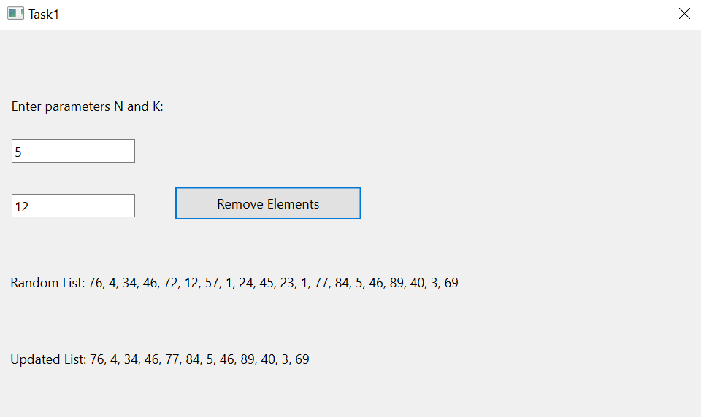

**Завдання №2 :**

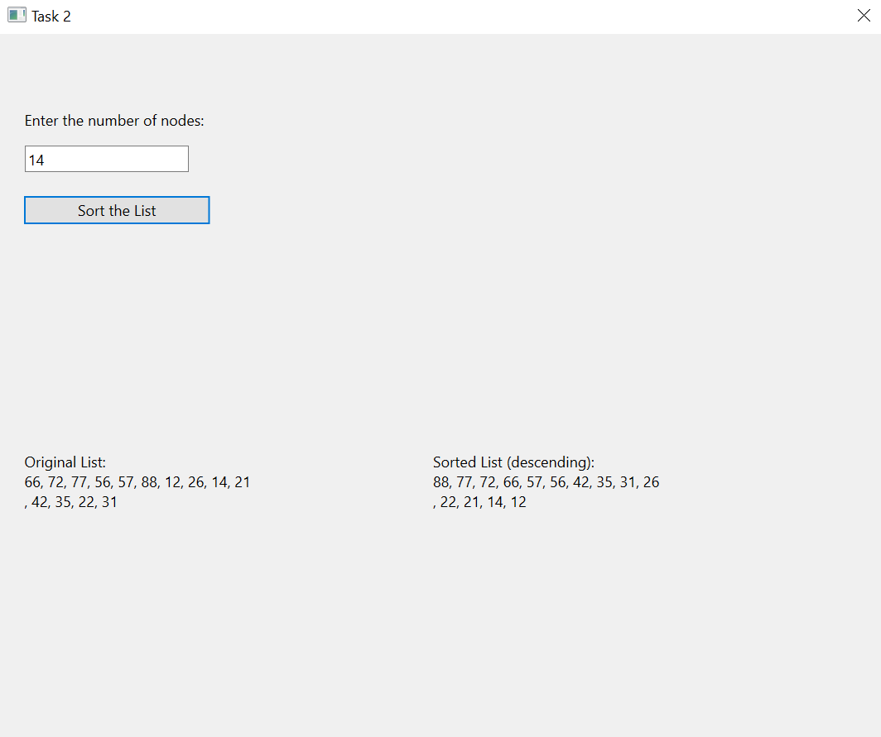

**Завдання №3 :**

